Class exercise 4-5 change multiple images

Open html change-image.html.

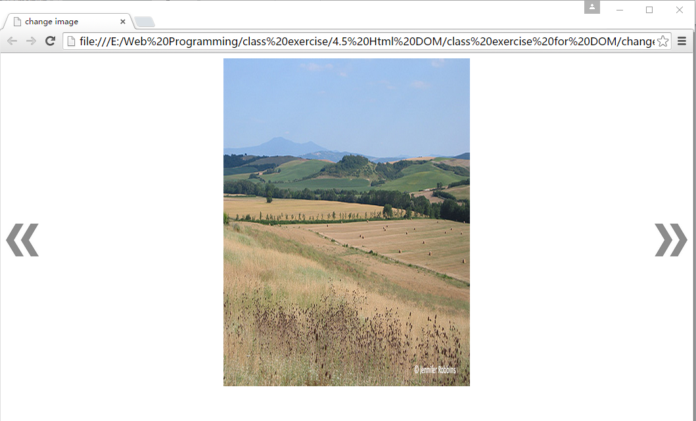

When user clicks left arrow, show the previous image. add new function changeToPreviousArrow()，Then you move the left arrow and right arrow to correct position by CSS.

